Pharma: AI-Driven Drug Repurposing Platform

Drug Repurposing can help in saving cost of new drug development as this drug can be used for other diseases. Each drug consists of different formulas composition, genes details, symptoms and chemical details to cure diseases. Various diseases may have same symptoms and can use same formula to cure those diseases.

So in propose work we are employing AI algorithms to train on Drug Reposition (drug repurposing) dataset and this trained model can take different disease symptoms and drug composition details as input and then predict weather this drug can be used to cure what other diseases.

For accurate prediction we have experimented with multiple algorithms such as CNN and Random Forest and each algorithm performance is measured in terms of accuracy, precision, recall and FCSORE. In all algorithms CNN giving best accuracy.

This project can be used by researchers to share about their trails and can discuss with other peoples about new drug development. To secured user discursion we are employing Blockchain technology which has inbuilt support for secured and tamper proof data storage.

Blockchain store each records as transaction/block and associate each block with unique hash code and this hash code will get verified for subsequent block storage, if any block modified then result into different hash code and data tamper will get detected. This verification process make Blockchain secured and tamper proof.

Blockchain can store and retrieve data using Smart Contract which can be designed using SOLIDITY programming. This contract contains function which can be called by any programming language to store and retrieve data from Blockchain. To manage user discursion we have designed following smart contract

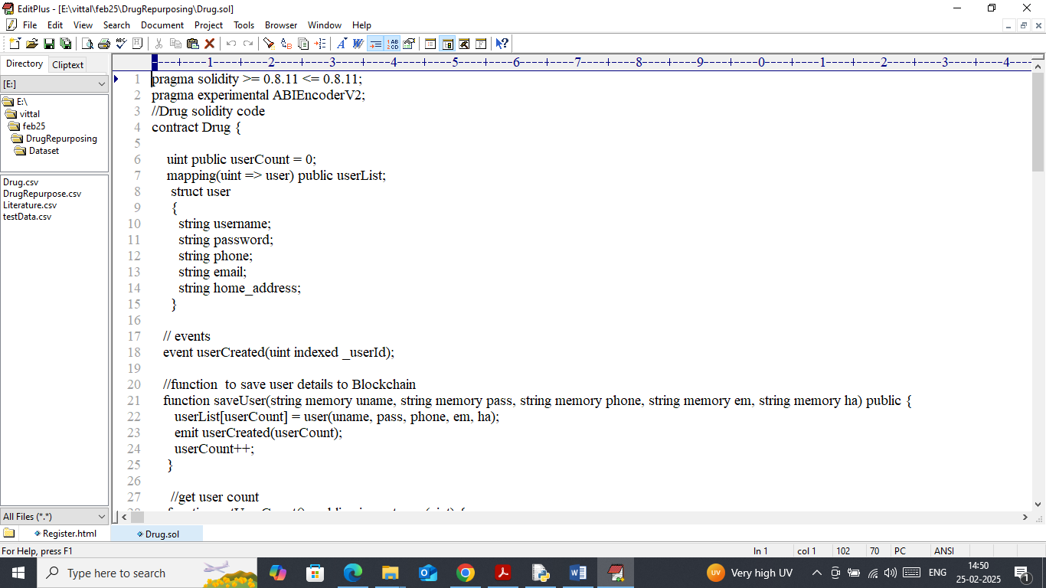

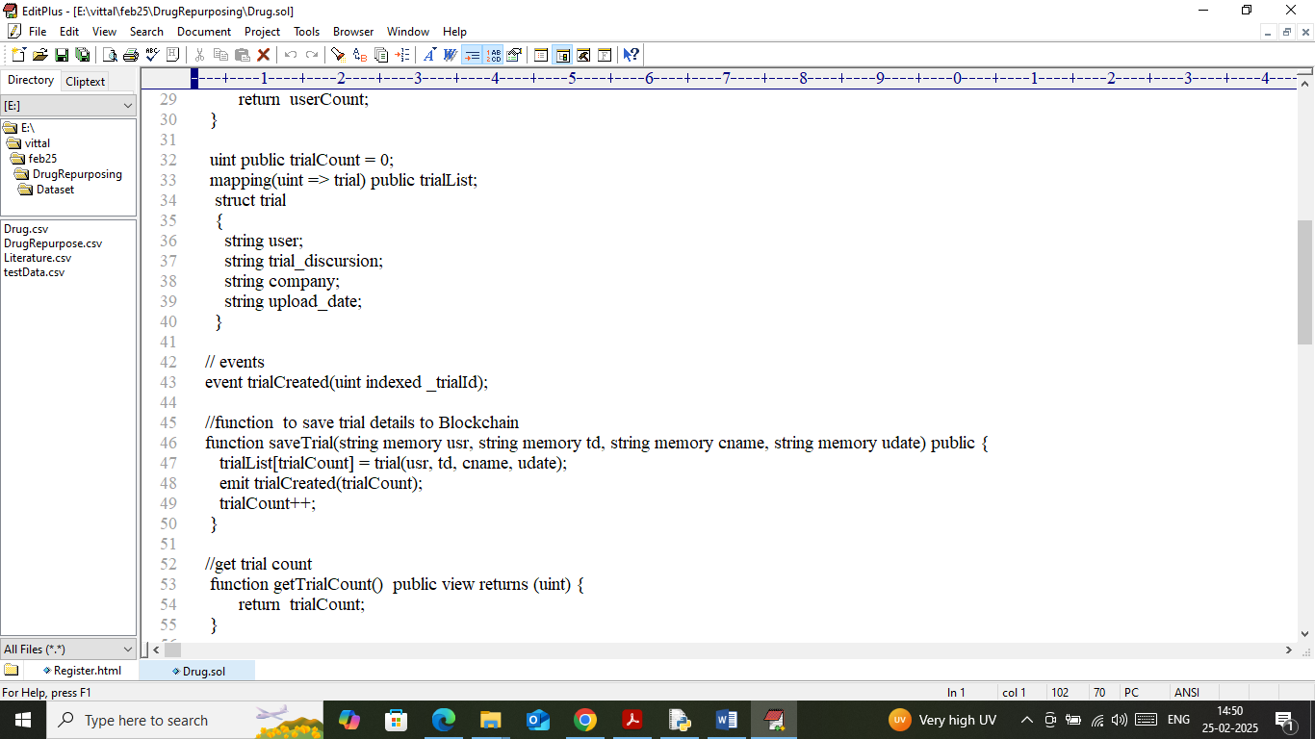

In above smart contract we have defined function to manage user and trial discursion in Blockchain. Now we need to deployed above contract to Blockchain Ethereum using below steps

1. First go inside ‘hello-eth/node-modules/bin’ folder and then look and double click on ‘runBlockchain.bat’ file to get below page
2. 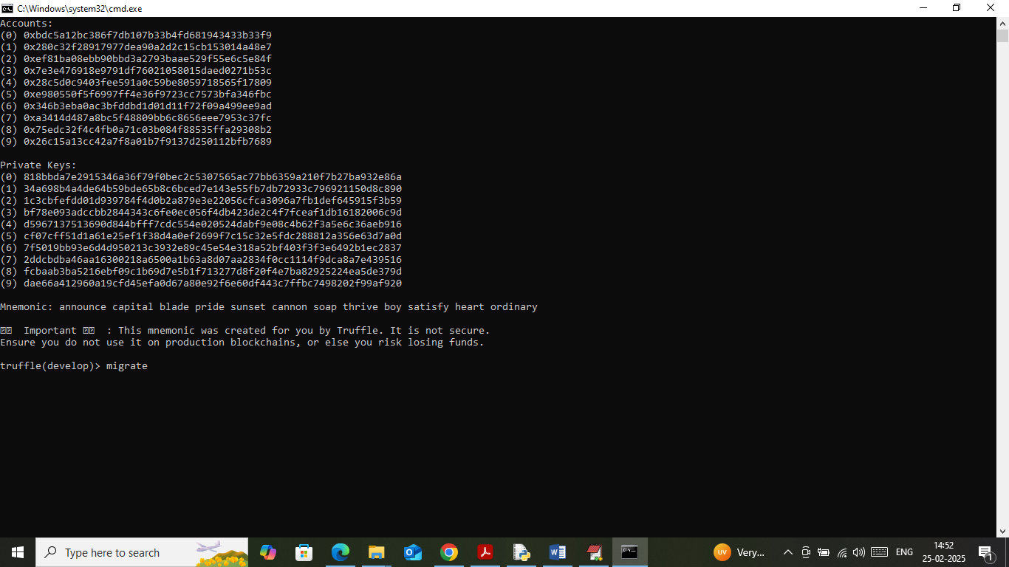
3. In above screen Blockchain Ethereum started with default account and private keys and now type command as ‘migrate’ and then press enter key to deploy contract and then will get below page
4. 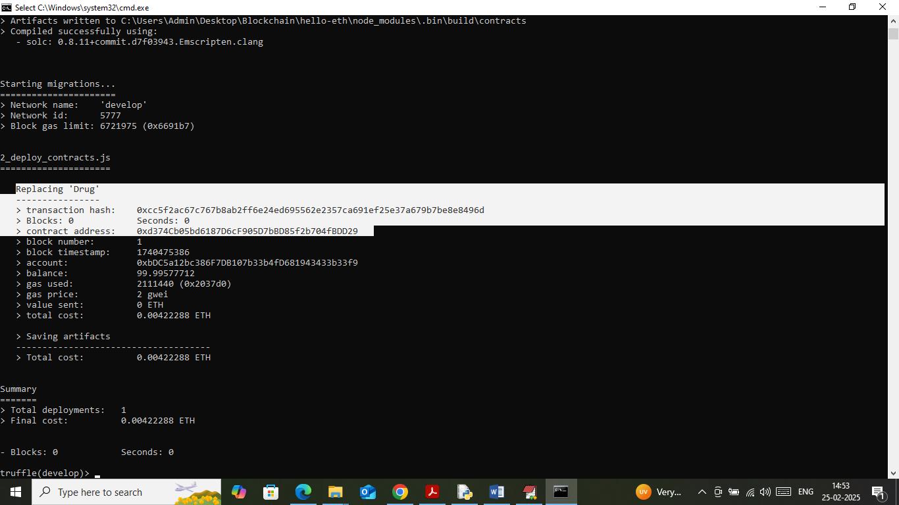
5. In above screen in white colour text can see ‘Drug’ contract deployed and running successfully and let it run till you execute project.

Modules Information

To implement this project we have designed following modules

1. New User Sign up: using this module user can sign up with the application and all user details will get saved in Blockchain
2. User Login: use can login to system
3. Load & Process Drug Data: using this module user can upload ‘drug repurpose’ dataset to application and then application will read and process dataset and then split dataset into train and test where application using 80% dataset to train AI algorithms and 20% dataset to test AI algorithm performance.
4. Train AI Models: 80% training data will be input to AI algorithms to train a model and this model will be applied on 20% test data to calculate prediction accuracy
5. Predict Alternate Uses: using this module user can upload drug test data and then AI algorithm will predict alternate uses of this drug
6. Share Trials: using this module user can discuss and share their drug trials with other users
7. View Trials: using this module all authenticated user can retrieve all trials from all users and can view them.

SCREEN SHOTS

To run project install python 3.7.2 and then install all packages given in requirements.txt file and then double click on ‘run.bat’ to start python web server and then will get below page

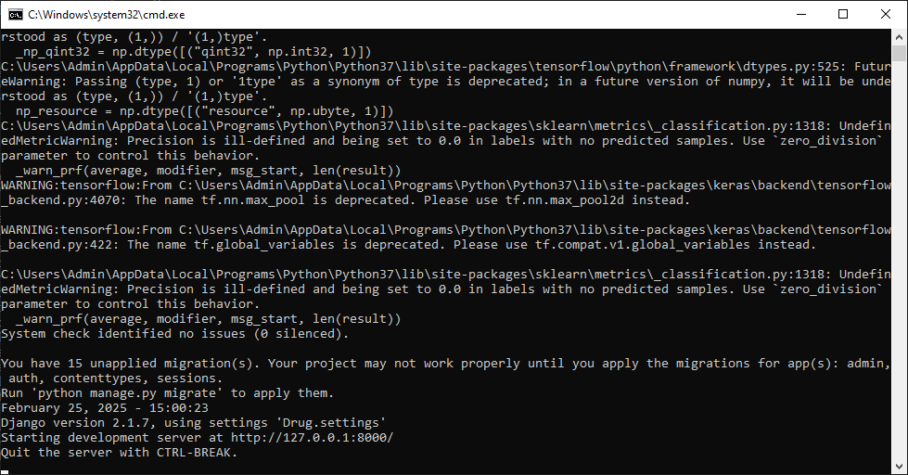

In above screen python web server started and now open browser and enter URL as <http://127.0.0.1:8000/index.html> and then press enter key to get below page

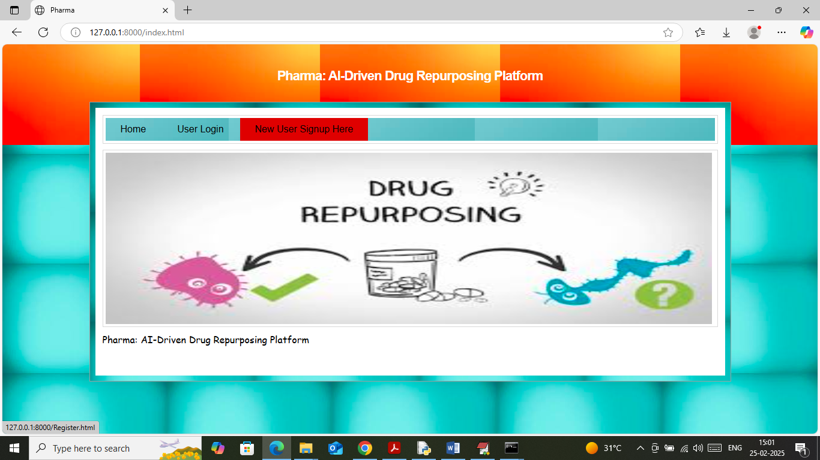

In above screen click on ‘New User Sign up’ link to get below page

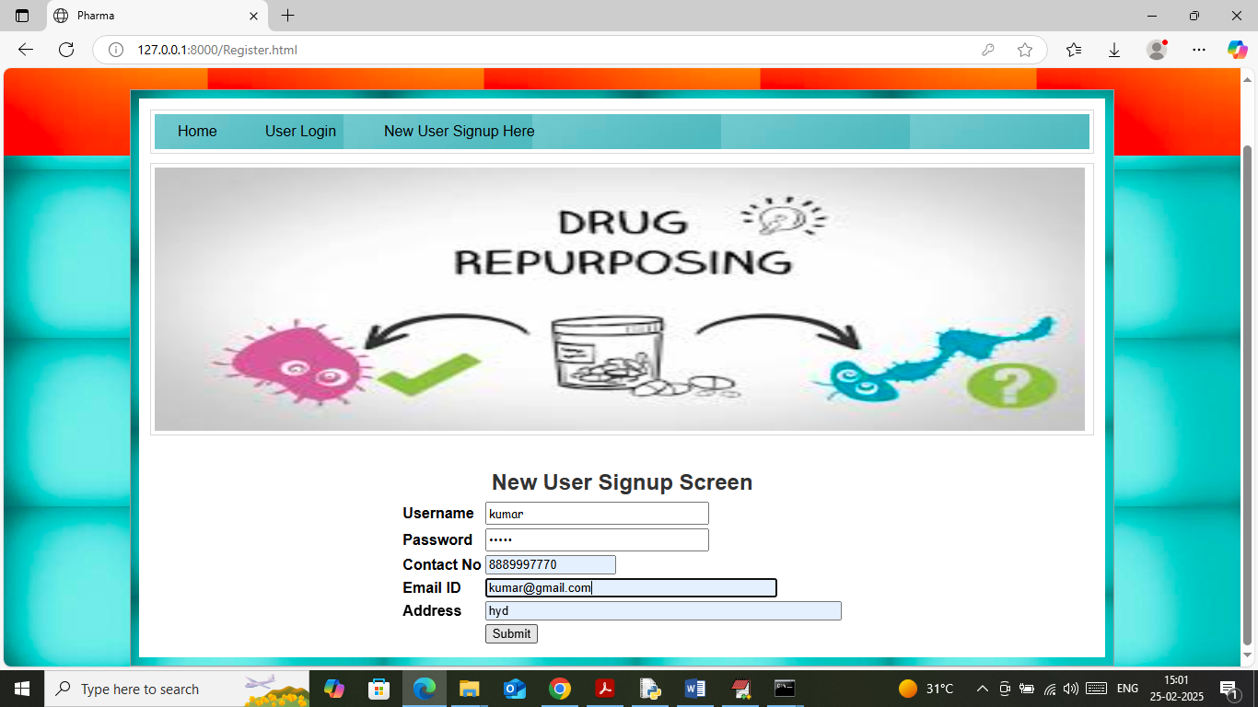

In above screen user is entering sign up details and then press button to save user data to Blockchain and then will get below page

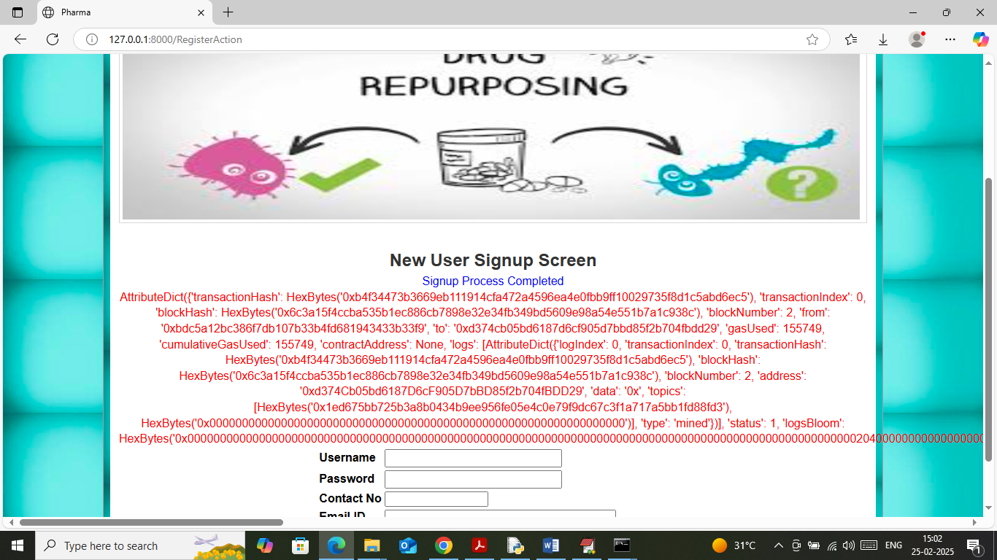

In above screen user sign up process completed and then in red colour text I am displaying all log details obtained from Blockchain after user data storage. This log contains details like Transaction no, hash code, Block no and many other details. Now click on ‘User Login’ link to get below page

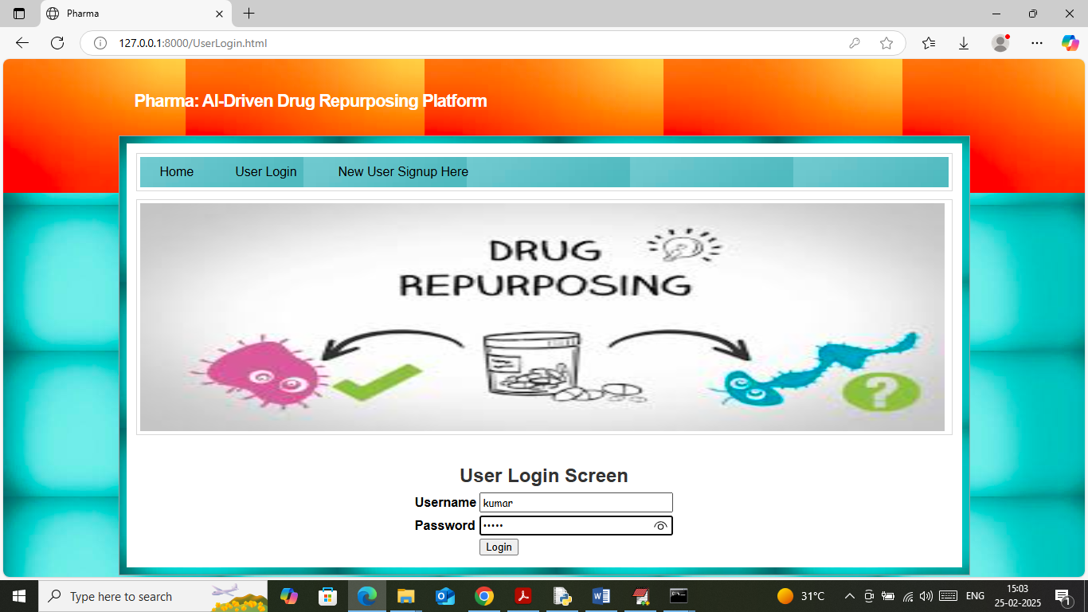

In above screen user is login and after login will get below page

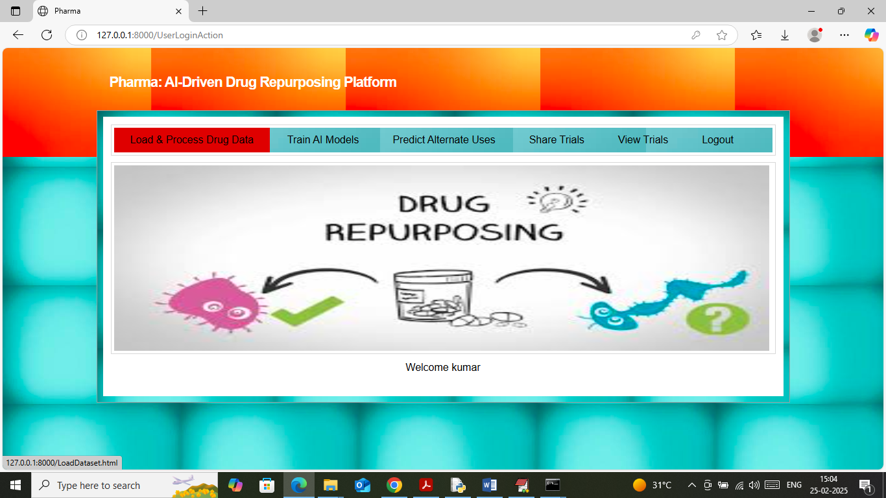

In above screen click on ‘Load & process Drug Data’ link to get below page

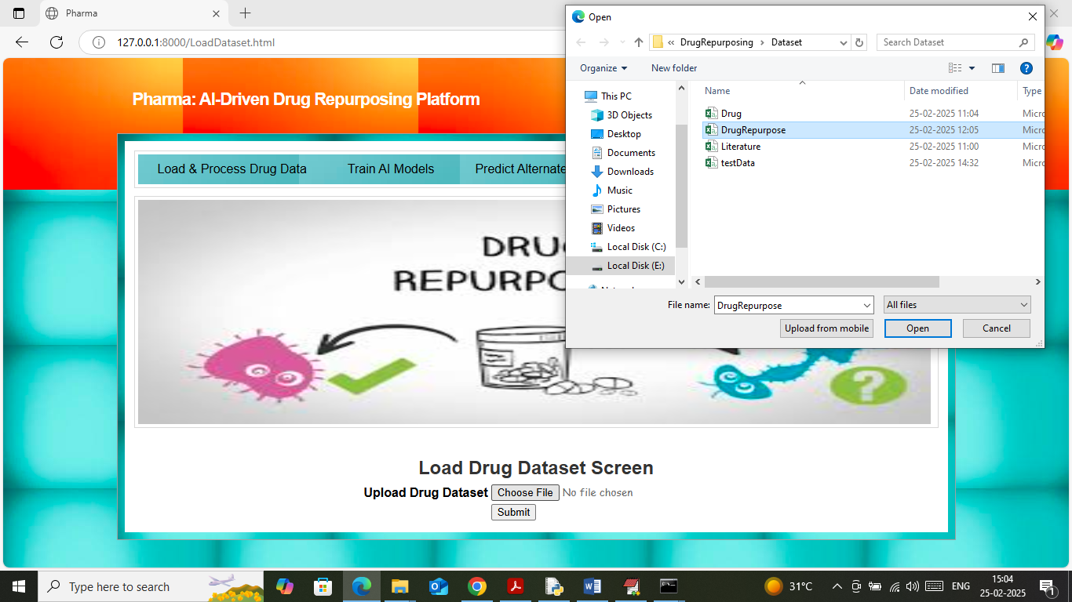

In above screen selecting and uploading ‘Drug Repurpose’ dataset file and then click on buttons to load dataset and then will get below page

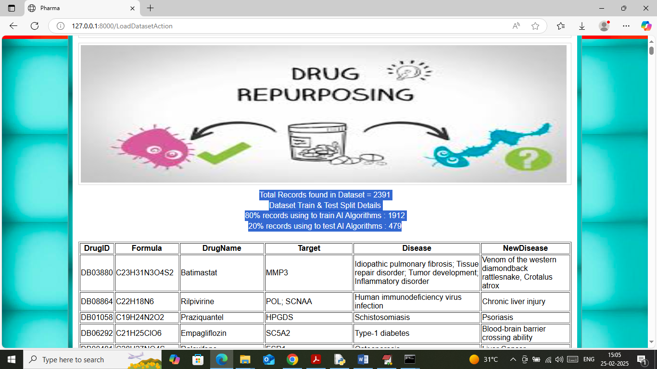

In above screen in blue text can see total records available in dataset and then can see train and test data size. In table format can see all dataset values like Drug name, formula and the disease name for which it can be used along with new disease name. Now click on ‘Train Models’ link to train AI algorithms and then will get below page

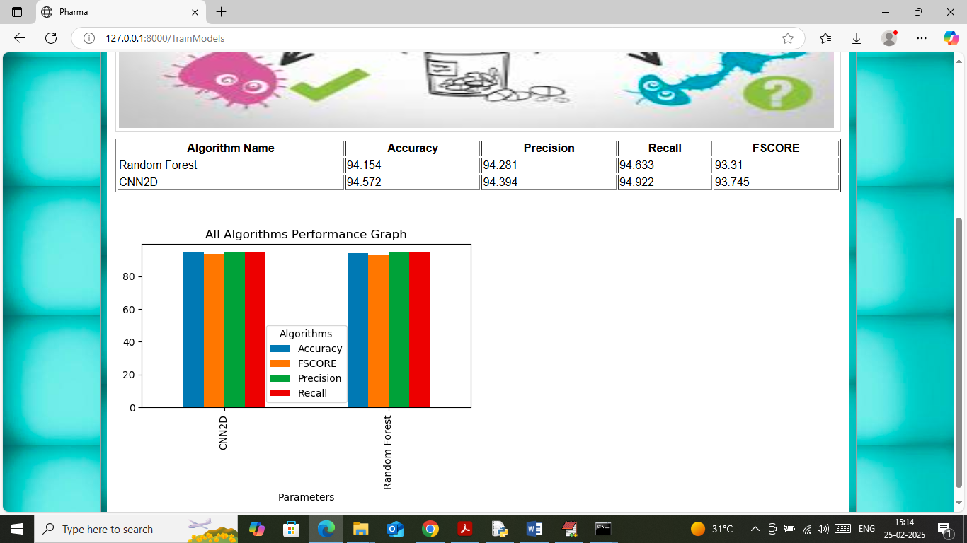

In above screen in table format can performance of each algorithm in form of accuracy, precision, recall and FSCORE. In graph also we are comparing both algorithm performance where x-axis represents algorithm names and y-axis represents accuracy and other metrics in different colour bars. In both algorithms CNN got high accuracy. Now click on ‘Predict Alternate Uses’ link to get below page

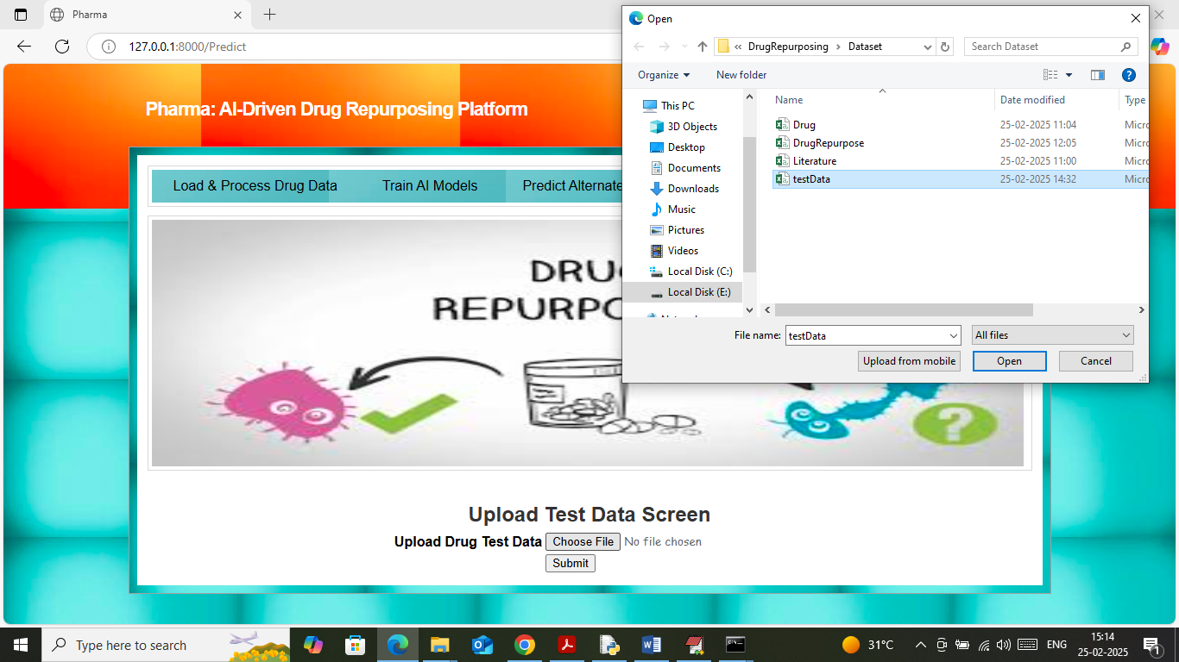

In above screen selecting and uploading ‘testData.csv’ file and then click on ‘Open and submit’ button to get below page

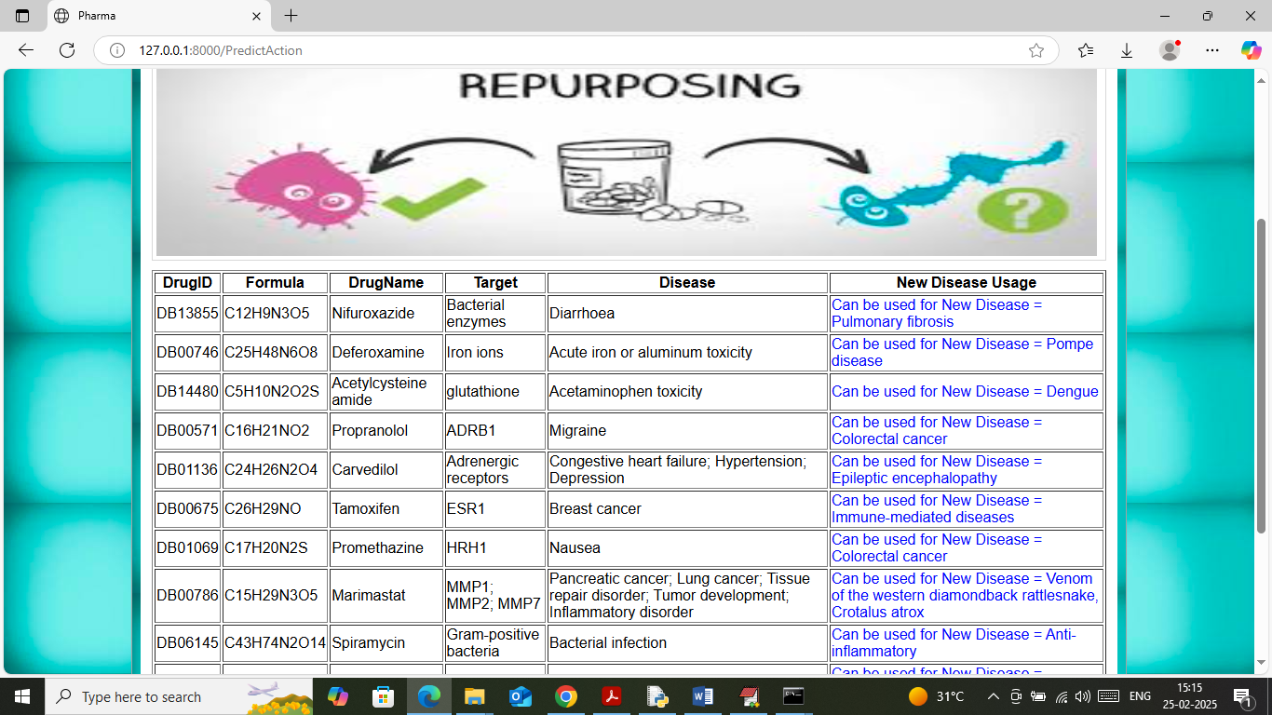

In above screen in table format we can see drug and formula details and in blue text can see AI predicted which other new disease can be cured with this drug. In each row displaying different drug along with curing next disease name. Now click on ‘Share Trials’ link to share discursion on new medicines with other users

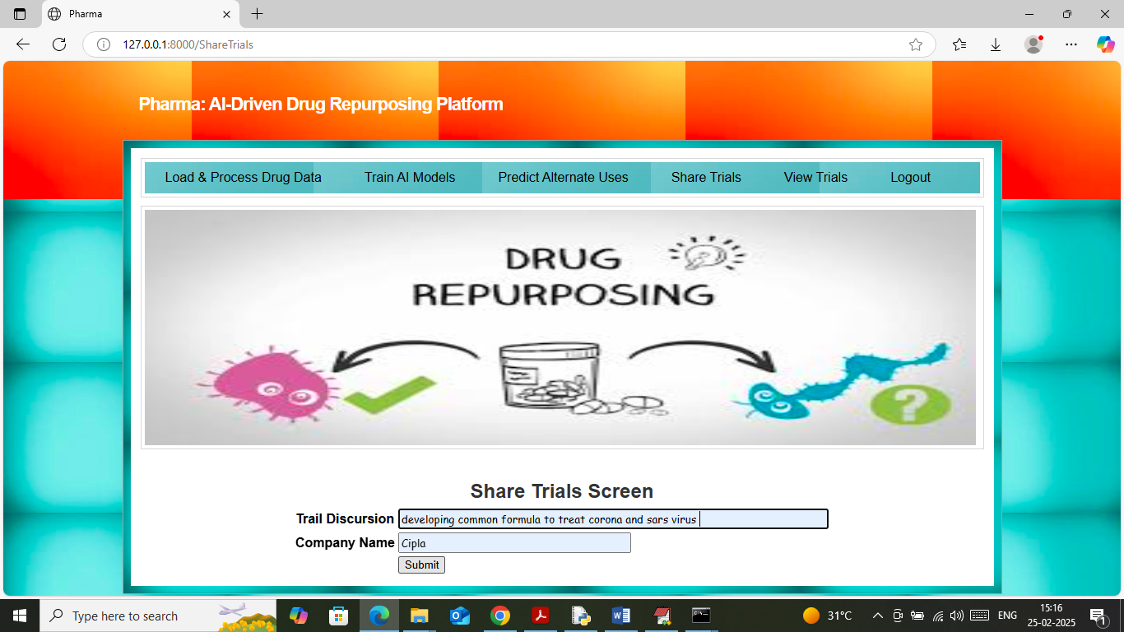

In above screen user is adding new trial or idea to Blockchain which can be share and access by other users and then will get below page

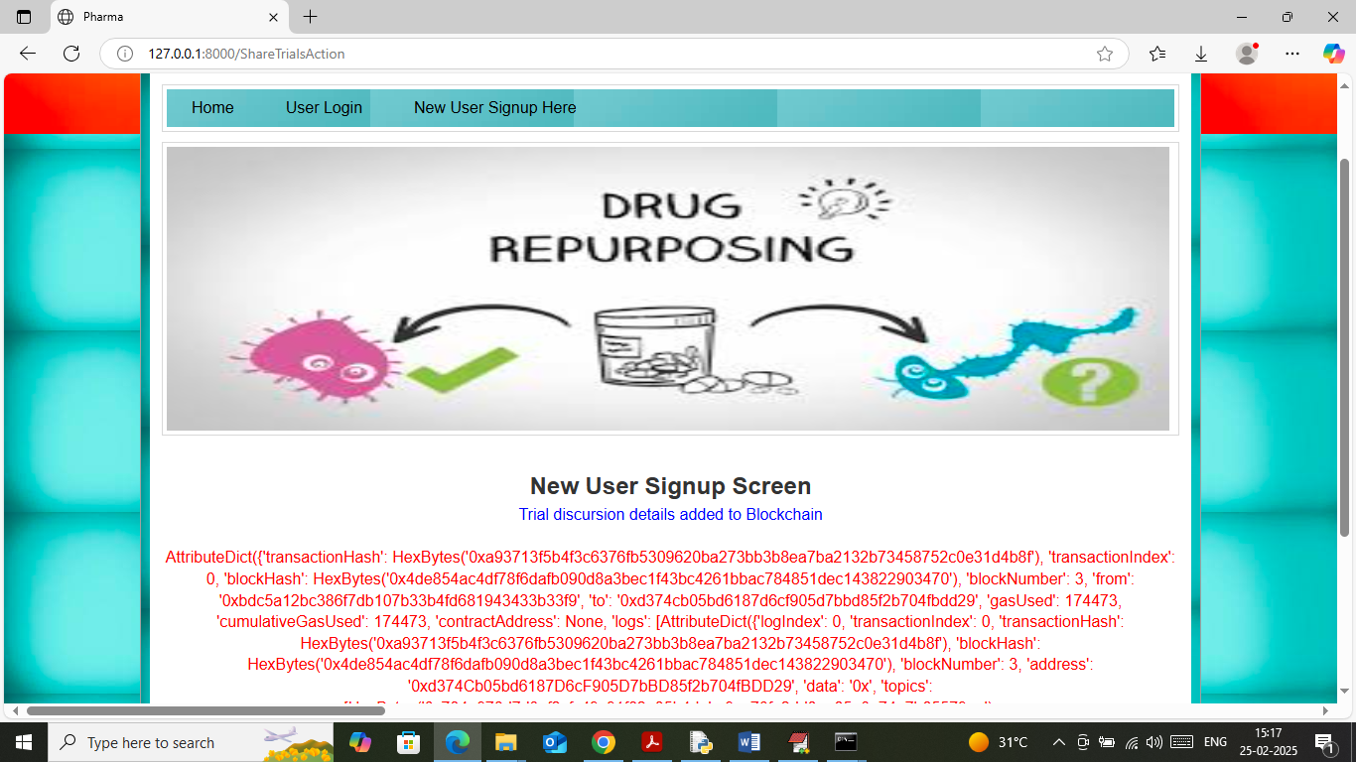

In above screen discursion details added to Blockchain and now click on ‘View Trials’ link to view previous discursion like below page

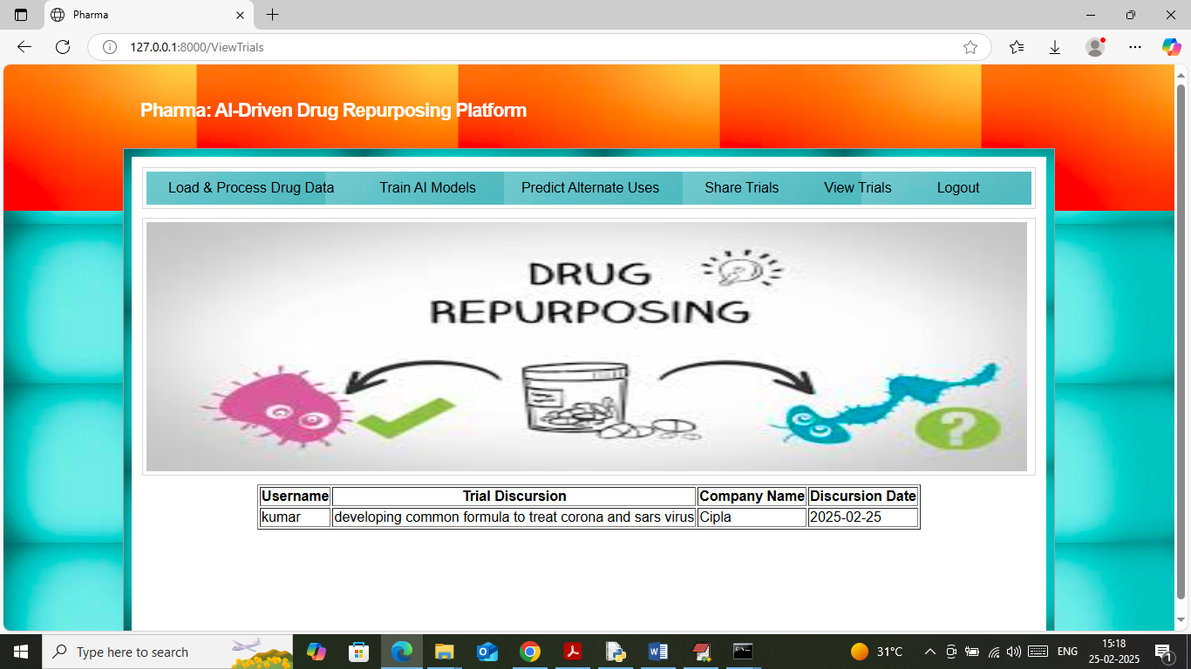

In above screen table format user can view trials discursion and experiments of different users.

So by using above screens you can perform drug repurposing along with secured sharing of discursions.